**Introduction**

*Overview of the painting service and interior works*

i**) what is a painting service**

A painting service is an excellent way to quickly and cost-effectively spruce up your home. Painting services can provide professional quality results in just a few days, and with competitive rates, they are a great choice for homeowners looking to upgrade their interior. A painting service can help take your home to the next level with color choices, specialized finishes, and an overall improved aesthetic. With a wide variety of options and experienced professionals, a painting service offers a great way to give your home a facelift.

**ii) what are the benefits our of a painting service**

Painting can be a daunting and time-consuming job, especially if you are trying to complete the task yourself. Hiring a professional painting service can provide a wealth of benefits. Not only can you be sure of high-quality results, you’ll also save time and money, since a painting service can complete the project in a fraction of the time. Professional painting services can also help you choose the right paints and finishes, and provide advice to ensure that the job is done correctly. Hiring a painting service is the perfect way to quickly and easily get a beautiful, lasting paint job.

**iii ) different types of paint to choose from**

Choosing the right paint is important, and there are many different types of paint to choose from. For walls, you can select latex or oil-based paints, which come in a variety of sheens and finishes. For outdoor projects, there’s alkyd, epoxy, and silicone paint, which provide better durability and protection. For walls and woods you can find emulsion, polyurethane and acrylic paint, each with its own unique application and effects. With so many choices, you can find the perfect type of paint for whatever project you’re tackling!

**2.Common interior works to upgrade your home**

*Upgrading Your Home Just Got Easier With These Interior Works!*

1. Install New Flooring – Whether you choose hardwood, tile, or carpet, a fresh floor will instantly brighten and modernize your home.
2. Paint the Walls – With paint, you can completely transform a room. Choose colors that fit your home decor style and bring out its best qualities.
3. Hang Curtains or Drapes – Installing curtains or drapes is an easy way to add style and warmth to any room.
4. Replace Light Fixtures – Outdated light fixtures can make a room look tired and dated. To instantly update your interior, look for modern fixtures.
5. Add a Rug – Whether you choose a statement piece or something more subtle, rugs are a great way to ground a space and add instant texture and color.

**3. Tips before hiring a painting and interior works service**

Get the Most Out of Your Painting and Interior Works Project: 7 Tips for Hiring the Right Service

1. Plan Ahead: How to Ensure a Smooth Painting and Interior Works Project

2. Make It Last: Pro Tips for Hiring the Right Painting and Interior Works Service

3. Know Your Budget: Tips for Finding the Right Painting and Interior Works Service at the Right Price

4. Get Expert Advice: A Guide to Choosing the Best Painting and Interior Works Service

5. Go the Extra Mile: Essential Considerations for Hiring the Right Painting and Interior Works Service

6. Research and Compare: How to Find the Best Painting and Interior Works Service

7. Time to Start Shopping Around: Tips for Choosing a Reliable Painting and Interior Works Service

**4.how painting service and interior work service can make homes look beautiful**

Painting services and interior work services can give homes a new look and make them look beautiful. From selecting the right paint colour and texture to adding new furniture or fixtures such as lighting or cabinetry, these services can transform a home’s overall look and design. Professional painting services also ensure that the interior and exterior painting is completed with precision, giving the home a beautiful and flawless finish. Additionally, interior work services can provide access to interior decorators who can coordinate furniture and other elements for an overall improved look.

**About us**

Aashaar Trading and Services was earlier launched in 2017 under the name Quest Home Solutions. Initially, it was launched with only one main goal, i.e., for customers who want to paint their houses in the most perfect manner and with the highest quality. Then it realized this was not the only aim but started working with the idea to bring the correct method and true quality of this painting service to the customers without any shadowing. The dependence on interior design also began earlier. As a result, today we have satisfied more than 200 clients through our efficient guidance and service.

**Services offered**

1.Painting advice

2. Interior and exterior painting service

3. Wood polishing

4. waterproofing

Colour consultancy

Wallpaper

Interior works

Carpenter work

Electrical work

Plumbing Work

**Products offered**

1. Electrical lighting and fittings

**Types of paints and Painting service**

**Types of paints**

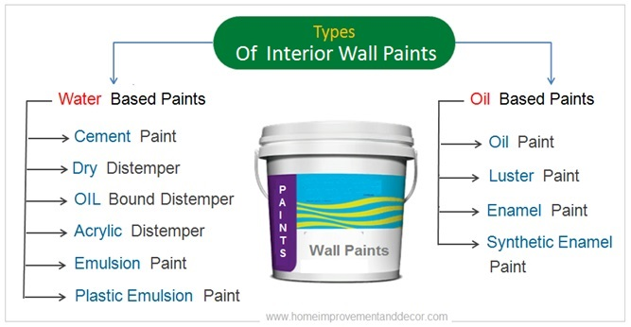

1. **Interior and exterior painting services**

Selection of types of paints

When it comes to selecting the right types of paint products and painting methods for walls, there are several factors to consider, such as the surface condition, desired finish, durability, and personal preferences. Here are some commonly used paint types and painting methods:

* 1. **Latex or Acrylic Paint**: Latex or acrylic paint is one of the most popular choices for interior walls. It dries quickly, has minimal odor, and is easy to clean up with water. Latex/acrylic paints are available in a wide range of sheens, from matte to high-gloss, and provide good coverage over most surfaces.
  2. **Oil-based Paint**: Oil-based paint is typically used for high-traffic areas or surfaces that require extra durability, such as kitchen walls or cabinets. It provides a smooth and durable finish but requires mineral spirits for cleanup.
  3. **Primer**: Primer is an essential product to apply before painting walls, especially if the surface is porous, damaged, or newly constructed. It helps to seal the surface, improve paint adhesion, and promote an even finish.
  4. **Textured Paint:** Textured paint can be used to create unique finishes on walls, such as a stucco or sand-textured effect. It is available in various textures and can help to hide imperfections on the wall surface.
  5. **Chalkboard Paint**: Chalkboard paint is a fun and functional option for walls, especially in kitchens or children’s rooms. It provides a chalkboard-like surface that can be written on and easily wiped clean.
  6. **Roller Painting**: Roller painting is the most common method for painting walls. It involves using a roller brush attached to a long handle to apply paint in broad strokes, covering large areas efficiently.
  7. **Brush Painting**: Brush painting is suitable for smaller areas, edges, or corners that cannot be reached with a roller. It requires a high-quality paintbrush with bristles suitable for the type of paint being used.
  8. **Spray Painting**: Spray painting is an efficient method for painting large areas quickly. It provides a smooth and even finish, but proper equipment and ventilation are necessary to avoid overspray and achieve a professional result.

Before starting any painting project, it’s crucial to prepare the walls properly by cleaning, patching any imperfections, and applying a suitable primer. Additionally, consider factors such as color selection, surface preparation, and application techniques to ensure a successful and long-lasting paint job*.*

*b.* ***Color selection***

We at Aashaar home solutions guide our customers in Selecting the right shade of paint. And we feel it is an important step in any painting project. The ideal shade should fit the overall design of the room while being complementary to the other colors used in the space. Be sure to sample a few colors and view them in daylight before making a final selection.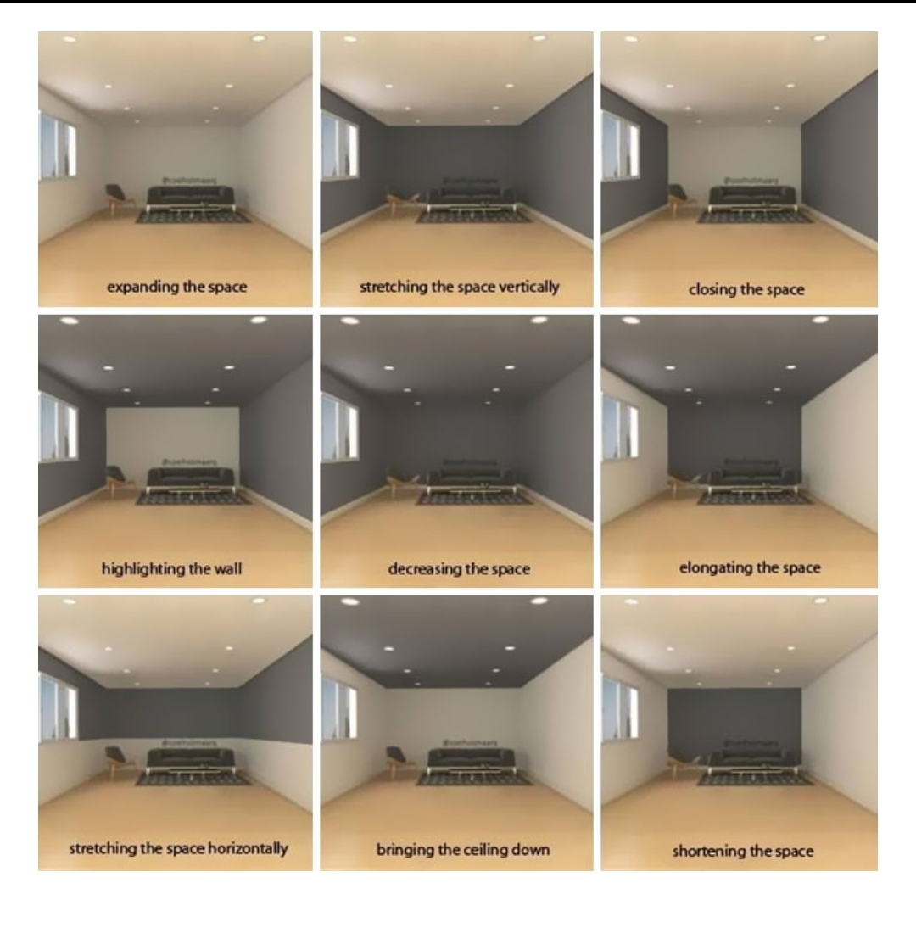

*c.* ***Types of paint finishes***

Satin finish

Flat/Matt finish

Dead Matt

Egg shell finish

Semi gloss

Gloss

High gloss

**Wood finishes**

* **Stain**: Staining is a common wood finishing method that enhances the natural color of the wood while also adding protection. Stains penetrate the wood pores, bringing out its grain and giving it a beautiful, rich color. Stains can be oil-based, water-based, or gel-based.
* **Varnish**: Varnish is a transparent, protective wood finish that adds a glossy or satin sheen to the wood surface. It provides excellent durability and resistance against wear, moisture, and UV rays. Varnishes can be oil-based, water-based, or polyurethane-based.
* **Lacquer**: Lacquer is a clear, durable finish that is typically sprayed onto the wood surface. It dries quickly, provides a high-gloss finish, and offers excellent protection against scratches, heat, and chemicals.
* **Shellac**: Shellac is a natural resin secreted by the lac bug, which is then refined and mixed with alcohol to create a wood finish. It dries quickly, offers good protection, and provides a glossy finish. Shellac is often used as a sealer or primer before applying varnish or paint.
* **Wax**: Wax is applied to the wood surface to create a soft, smooth finish and enhance the wood’s natural beauty. It provides moderate protection against scratches and marks, but it is not as durable as other finishes. Wax can be applied alone or over other finishes as a topcoat.
* **Paint**: Painting is a method of applying colored pigments to the wood surface for both decoration and protection. It allows for complete coverage and hides the natural wood grain. Paint can be oil-based, water-based, or latex-based depending on the desired finish and application.
* **Polyurethane**: Polyurethane is a clear, durable finish that provides excellent protection against wear, heat, moisture, and chemicals. It is commonly available in oil-based or water-based forms and can be applied as a clear coat or tinted with pigments for a slight color change.
* **Epoxy**: Epoxy is a two-part adhesive that can also be used as a wood finish. It creates a thick, glossy, and durable coating that enhances the wood’s appearance and provides high resistance against scratches, stains, and moisture.
* **Oil**: Oil finishes, such as linseed oil, tung oil, or Danish oil, penetrate into the wood to nourish and protect it. They enhance the wood’s natural color and create a low-sheen, matte or satin finish. Oil finishes require regular maintenance and reapplication to maintain their protective properties.
* **Distressed or weathered finishes:** These finishes involve intentionally aging the wood surface to give it a distressed or weathered look. Techniques like sanding, scraping, or using special distressing tools are used to create a worn-out appearance. These finishes are often combined with stains or paints to achieve the desired effect.

**Waterproofing**

There are several types of waterproofing methods and materials used to protect various surfaces from water damage. Some common types of waterproofing include:

1. **Liquid Waterproofing Membrane**: This is a liquid-applied waterproofing system that forms a seamless, flexible membrane when it cures. It can be applied to various surfaces such as roofs, walls, basements, and concrete structures.
2. **Bituminous Coating**: Bituminous coatings are asphalt-based products that provide a waterproof barrier when applied to surfaces. They are commonly used for waterproofing roofs, foundations, and below-grade structures.
3. **Cementitious Waterproofing**: Cementitious waterproofing is achieved by applying a cement-based coating or slurry to the surface. It forms a dense, waterproof layer that can be used for various applications, including basements, swimming pools, and water tanks.
4. **Sheet Membrane Waterproofing**: Sheet membranes, typically made of materials like PVC or bitumen, are applied to the surface to create a barrier against moisture. They are commonly used for waterproofing roofs, basements, and balconies.
5. **Waterproofing Paints**: Waterproofing paints are specially formulated coatings that provide a waterproof barrier and can be applied to surfaces like roofs, walls, and concrete structures. They typically have elastomeric properties to allow for expansion and contraction.
6. **Bentonite Waterproofing**: Bentonite is a type of clay material that swells when it comes into contact with water, creating a waterproof barrier. It can be used as a sheet membrane or as a slurry applied to surfaces like foundations and below-grade structures.
7. **Polyurethane Waterproofing**: Polyurethane waterproofing involves the application of a liquid polyurethane sealant or membrane to create a flexible and durable waterproof barrier. It can be used for a variety of applications, including roofs, decks, and basements.
8. **Geo-Membranes:** Geo-membranes are synthetic sheets made from materials like PVC or HDPE (high-density polyethylene) that provide a waterproofing barrier. They are commonly used in larger-scale applications, such as landfills, ponds, and reservoirs.
9. **Waterproofing Admixtures**: Waterproofing admixtures are chemical additives that are mixed with the concrete or mortar mix to increase its water resistance. These admixtures work by reducing the size of capillary pores in the concrete, making it more resistant to water penetration.

It’s important to choose the appropriate waterproofing method and materials based on the specific structure and requirements to ensure effective and long-lasting protection against water damage.

**Interior Works**

*a. Types of wall treatments*

1. **Paint**: “A Fresh Coat of Paint to Bring Your Walls to Life!”

2. **Wallpaper**: “Bring Personality and Color to Your Walls with Wallpaper!”

3. **Wood Panelling**: “Add Warmth and Character with Wood Panelling!”

4. **Brick**: “Brick Walls Offer a Rustic and Timeless Feel!”

5. **Fabric**: “Add Depth and Texture with Fabric Wall Treatments!”

6. **Stone**: “Bring an Elegant Look to Your Home with Stone Walls!”

7. **Stencilling**: “Add a Creative Touch with Wall Stencils!”

b. **Flooring installation**

c. **Window treatments**

d. **Trim and moulding**

e. **Furniture selection and layout**

**Benefits of Hiring Professional Services**

1. **Expertise and Experience**: Professional services providers have specialized knowledge and experience in their respective fields. They are well-trained and have the necessary skills to handle complex tasks efficiently.

2. **Time and Cost Savings**: Hiring professionals can save you time and money. They can complete tasks more quickly and accurately, allowing you to focus on other important aspects of your business. Additionally, they can help you avoid costly mistakes and provide cost-effective solutions.

3. **Access to Resources and Technology**: Professional services providers have access to advanced tools, technologies, and resources that may not be available to you. They can leverage these resources to deliver high-quality results and stay updated with the latest industry trends.

4. **Scalability and Flexibility**: Professional services providers can easily scale their

**Why choose Aashaar Trading And Services**

1. **Safety**

There are several safety benefits that customers can get by Aashaar Trading And services:

* 1. **Expertise and Knowledge:** Aashaar service team have the necessary expertise and knowledge in our respective fields. They are trained and experienced in handling specific tasks, ensuring that the job is done correctly and efficiently. This reduces the risk of errors or accidents that could occur if the task was performed by someone without the necessary skills.
  2. **Safety Protocols and Regulations**: Professionals are well-versed in safety protocols and regulations related to their industry. They understand the potential risks involved in their work and take necessary precautions to ensure the safety of both themselves and the customers. They follow industry standards and guidelines to minimize any potential hazards.

3. **Proper Equipment and Tools**: Professional service providers have access to

b. **Quality**

There are several qualities that a customer can expect when hiring professional services:

1. **Expertise**: We have the necessary training and experience to deliver high-quality work and provide valuable insights and solutions.
2. **Reliability**: our team are committed to delivering their services in a timely and dependable manner. We understand the importance of meeting deadlines and fulfilling obligations to the customer.
3. **Accountability**: Aashaar service providers take responsibility for their work and are accountable for the outcomes. They strive to deliver results that meet or exceed customer expectations and are willing to address any issues or concerns that may arise.

4. **Customization**: Aashaar understand that each customer’s needs and requirements are unique. They are capable of tail

c. **Efficiency**

The efficiency of painting services can vary depending on several factors, including the size and complexity of the project, the skill and experience of the painters, and the tools and equipment used. However, in general, our painting services are known for their efficiency and ability to complete projects in a timely manner.

Our painters are trained and experienced in their craft, which allows them to work efficiently and effectively. They have the knowledge and skills to properly prepare surfaces, apply paint evenly, and achieve a high-quality finish. They also have access to professional-grade tools and equipment, which can help speed up the painting process.

Additionally, aashaar painting services often have a team of painters working together, which allows them to divide and conquer tasks, further increasing efficiency.

**Outline process**

Upon receiving an online inquiry from a customer, we will promptly schedule an appointment. During this appointment, we will take measurements at the customer’s location and provide them with an evaluation.

Once a customer has requested it, we will proceed to prepare a quotation for the project based on the measurements taken.

Upon receiving the quotation, the customer will finalize the project.

The project will consist of several steps:

Assistance in selecting the appropriate paint, shades and determining the necessary tasks for the project.

1. The first step involves selecting the appropriate materials for the project.
2. In the second step, we will allocate workers to the project.
3. The work will then begin and be regularly reviewed by a project manager.
4. Upon completion of the project, we will seek feedback from the customer regarding our work culture and the project itself.
5. Full payment will be received and settlement will be finalized.
6. Finally, we will request a review from the customer once the project is complete.

**Testimonials**

Work done right.! Right assistance of colour and quality, delivered fully finished house on a perfect given time, ppl were so flexible, so I could able to manage all my extra works.

Written by Ganesh, 2023-06-20

Likesome Very good painting work, I referred many persons for painting work, very clean and output is excellent . Price is reasonable, and working labours are very experienced persons.

Written by Ravi, 2023-06-18

Excellent service and suggestions provided by him and his team. Timely delivery with out any delay. Without any second thought would prefer him for any kind of painting work. Thanks again for all the efforts by aashaar

Written by Arun, 2023-06-17

Mr. Abdul has provided excellent service and suggestions during our house painting. He is highly skilled and professional in all kind of painting works.rnrnWithout any second thought I would suggest h

Written by Arun, 2023-06-17

Clean and Neat Painting Work

Written by Shainu, 2022-10-12

Mr. Abdul painting service was very good, he was dedicated to the work and was very keen on the finish and quality of work. I was more happy to see he played major role In giving quality finish to my

Written by Manikandan, 2022-07-29

I appreciate Mr.Abdul has given excellent ideas and suggestion for our home painting . I will wish him for great success for delivering quality homes painting and services .

Written by Tamil Selvan, 2022-07-29

**FAQs About Aashaar Painting services and Interior Works**

1. What types of painting services do you offer?

Aashaar painting service offers interior and exterior painting services, water proofing,woodpolish, floor painting and wallpaper installation services

1. How much does your painting service cost?

As we focus on the quality of the service the price are derived accordingly but still painting cost at Aashaar is as per market standards

1. How long does it typically take to complete a painting project?

It depends on the area, surface, and the type of work. Typically, a normal 1000 sqft carpet area house will take 2-3 weeks for a complete interior painting job.

1. Do you provide a warranty or guarantee for your painting work?

We provide a 1-year service warranty for the work done and a product warranty as specified by the product manufacturer.

1. Do you offer any additional services, such as wallpaper removal or drywall repair?

Yes , understanding the customers we offer additional services if possible

1. What type of paint do you use, and can I choose the color?

As We deal with most of the leading brands and their products such as Asian paints, Nippon paints, Dr.Fixit Viz., We use latex, emulsion, oil base and Pu range of paints etc..

1. How long does it typically take to complete a painting project?

It depends on the area, surface, and the type of work. Typically, a normal 1000 sqft carpet area house will take 2-3 weeks to complete an interior painting job.

1. Do you have insurance coverage in case of any accidents or damages during the painting process?

Yes the team members are covered with insurance

1. How do you prepare the surfaces before painting?

Initially with covering and masking of the non paintable surfaces, furnitures and fittings. Treating cracks on the paintable surface, filling, sanding,spot putty if necessary , priming the surface and then paint coat, the same case applies for exterior wall surfaces if need water wash will be done. Wood finishes has unique process depends on the type of woods

1. Do you offer any eco-friendly or low ?

All the painting products offered by us are eco friendly green assured

**Instagram**

aashaartradingandservices